# Contents

Contents 1

ENVIRONMENT READINESS 3

Let us ensure the Server is up and running. For this, follow the below steps. 3

NOTE: 5

HOME PAGE IMPLEMENTATIONS 6

Implement Header Functionality 6

Skeleton Output 6

Expected Output 6

Guidelines 7

Slider Image Implementation 7

Skeleton Output 7

Expected Output 7

Guidelines: 8

Settings Implementation 8

Skeleton Output 8

Expected Output 9

Guidelines 9

RTL Functionality 10

About Us Block Implementation 10

Skeleton Output 10

Expected Output 10

Guidelines: 11

Menus Implementation 12

Skeleton Output 12

Expected Output 12

Guidelines 12

Reach Us Implementation 13

Skeleton Output 13

Expected Output 13

Guidelines 13

Implement Feedback/Review 14

Guidelines 15

MENU BAR 16

Implement Contact Page 16

Skeleton Output 16

Expected Output 17

Guidelines 17

Implement About Us Page 18

Skeleton Output 18

Expected Output 18

Guidelines 19

Contents for About pages: 19

===>About Us 19

===>The History 19

===>Our Story 19

===>Since 20

Unit Test: 20

Responsive Requirements: 21

# ENVIRONMENT READINESS

## Let us ensure the Server is up and running. For this, follow the below steps.

1. Extract skywave-server21Sept2021 zip file

(Example: File is extracted in **D:\Angular12\skywave-server** >)

1. Go to above the location of skywave-app ( **cd D:\ Angular12\skywave-server**)
2. **npm install --save-exactexpress@4.17.1 cors@2.8.5**  (You could see similar messages like below)

npm WARN old lockfile

npm WARN old lockfile The package-lock.json file was created with an old version of npm,

npm WARN old lockfile so supplemental metadata must be fetched from the registry.

npm WARN old lockfile

npm WARN old lockfile This is a one-time fix-up, please be patient...

npm WARN old lockfile

added 55 packages, and audited 56 packages in 10s

found 0 vulnerabilities

1. node src/index.js

Skywave server listening on port 8080

1. **Do not disturb the above Terminal/CMD window.**
2. **Extract skywave-angularapp.zip** to a folder

* Go to a folder which already exists else create a folder

**(Example : D:\Angular12\** AngularApp**]**

* **Copy the skywave-angularapp.zip to the above folder**
* Extract the zip here.

1. Run **npm install**

(In same location: cd D:\Angular12\AngularApp**)**

(You could see similar messages like below)

> skywave@1.0.0 preinstall

> npx npm-force-resolutions

added 1761 packages, and audited 1762 packages in 4m

93 packages are looking for funding

run `npm fund` for details

7 moderate severity vulnerabilities

To address issues that do not require attention, run:

npm audit fix

To address all issues (including breaking changes), run:

npm audit fix --force

Run `npm audit` for details.

1. Run **ng serve or ng serve --open** 
   * + - (In same location: cd D:\Angular12\AngularApp**)**

(You could see similar messages like below)

** Angular Live Development Server is listening on localhost:4200, open your browser on http://localhost:4200/ **

√ Compiled successfully.

✔ Browser application bundle generation complete.

9 unchanged chunks

Build at: 2021-09-30T02:45:42.515Z - Hash: f647748b7c02952f5d43 - Time: 6792ms

√ Compiled successfully.

✔ Browser application bundle generation complete.

9 unchanged chunks

Build at: 2021-09-30T02:45:49.069Z - Hash: f647748b7c02952f5d43 - Time: 5697ms

√ Compiled successfully.

1. The application is now running in **localhost:4200**
2. **Launch the application using the url** http://localhost:4200/

**skywave-skeleton.zip is a skeleton app:**

Skeleton - To be used by the associate to incorporate the functionality as shown in the working Angular App.

**Note: For Skeleton: << Node Server instance should be started and the API to be consumed by the associate to achieve the dependent functionality>>**

# NOTE:

Images and Contents to be shown for the respective images are mentioned then and there and also at the end of this document. In some cases, we also provided the respective mat-icons names that need to be used. Feedbacks/Reviews are stored in JSON and shown against the respective menu.

# HOME PAGE IMPLEMENTATIONS

Let us split the Home page into following sections

1. Header
2. Navbar
3. Image and Contents for Carousel (Slider)
4. Menu
5. Get in Touch -Reach Us
6. Footer

# Implement Header Functionality

The page starts with a header with contact information of the restaurant.

## Skeleton Output

Associates shall get an empty red header without icons and they have to implement and achieve the expected output as shown under the section Expected Output.

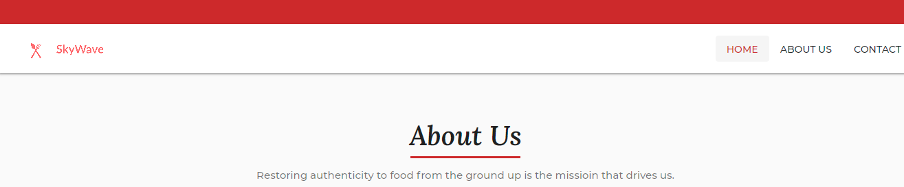

## Expected Output

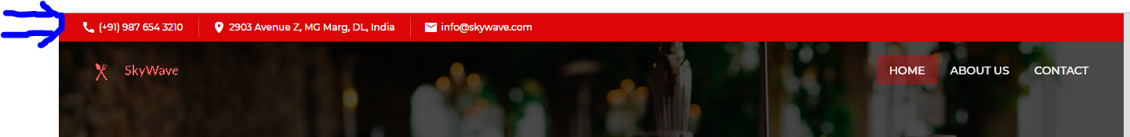

## Guidelines

Header Strip - Phone NO, Address & Email

File Name: app/theme/components/contacts/contacts.component.html

1. mat-icon:
   1. call,
   2. location_on
   3. mail
2. Values:
   1. (+91) 987 654 3210,
   2. 2903 Avenue Z, MG Marg, DL, India
   3. [info@skywave.com](mailto:info@skywave.com)

# Slider Image Implementation

## Skeleton Output

After the menu bar and before About Us, show a slider Image.

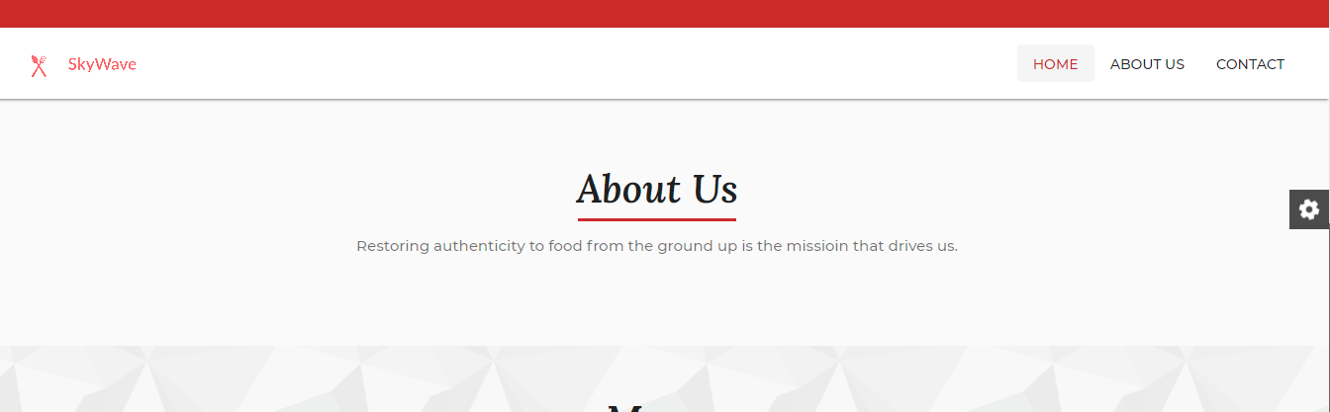

## Expected Output

After the Menu bar ( Home, About & Contact ) and before the About Us block in the homepage the following Slider image with required texts to be implemented.

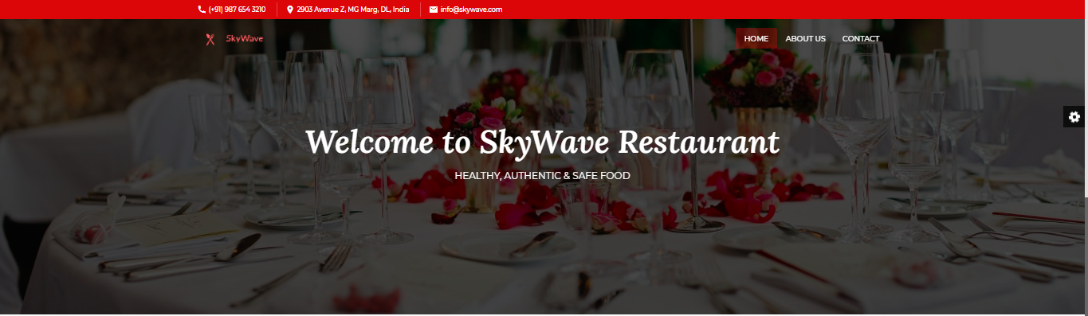

In Slider : Only one Image needs to be shown to user with “static content” as

Welcome to SkyWave Restaurant

HEALTHY, AUTHENTIC & SAFE FOOD

1. Image should be moving slowly on the background (animated background image)
2. Static Text should be shown (center aligned)
3. On this image, you need to show settings” Icon 
4. While clicking the above settings, it should open up a window

## Guidelines:

Changes to pages/home.component.html.

Use shared/header-image component to achieve it.

* assets/images/others/homepage.jpg
  + title 🡺 Welcome to SkyWave Restaurant
  + Description 🡺 Healthy, Authentic & Safe Food

# Settings Implementation

## Skeleton Output

It will have only the Sticky Menu ToolBar and the associate must implement the RTL functionality as shown in the expected output below.

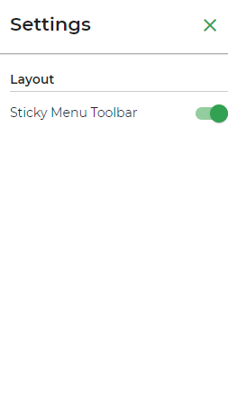

## Expected Output

When you click settings the pop-up window should be shown like below. When the user turns-on the sticky menu toolbar, the header is shown always even when we scroll down into pages. If it is turn-off, the header menu toolbar is not shown when we scroll Home/Contact uS/About Us pages) **By default, it is turn-on and RTL is Turn-OFF**

1. Sticky Menu functionalities are made available for you. You need to implement (RIGHT-TO-LEFT (RTL)
2. RTL TURN ON/OFF functionality: When turn on, the window moved to left

## Guidelines

**Variable defined for your use in (app/app.settings.ts)**

* 1. **public stickyMenuToolbar: boolean,**

## RTL Functionality

Changes to Pages/Pages.component.html

Use **mat-slide-toggle**, as used in Sticky Menu Toolbar

# About Us Block Implementation

## 

## Skeleton Output



In the About Us block, details about the restaurant are to be shown. Image, description with a READ MORE button to be implemented. When READ MORE is clicked it will take the user to About Us Page.

## Expected Output

## Guidelines:

**File-Name:**

src/app/pages/home/home.component.html

<mat-card>

<!-- Your Code for showing about-us image with its description -->

</mat-card>

**Image:**

assets/images/others/about-us.jpg

Bring the layout as required. Use shared/header-image component and mat-card to achieve it.

Use following Images for the layout

assets/images/others/about.jpg, assets/images/others/about-1.jpg & assets/images/others/about-2.jpg

Content:

In 2007, the SkyWave group opened its first hotel outside India, the SkyWave Hotel in Sana'a, in Yemen and in the late 2019s, acquired interests in the Court Hotel (now comprising SkyWave 51 Gate Suites and Residences and Court, A SkyWave Hotel) in London.In 2020, the SkyWave group acquired, under a license agreement, each of the SkyWave in Bengaluru, in Chennai and Sammoy Hotel in Ooty. With the opening of the SkyWave in Bengaluru, the SkyWave Group made its foray into Bengaluru. The five-star deluxe hotel, SkyWave in Kolkata, was opened in the year 2020, and with this, the SkyWave group became the only hotel chain in India with a presence in the six major metropolitan cities of India, namely Mumbai, Delhi, Kolkata, Bengaluru, Hyderabad, and Chennai.

Concurrently with the expansion of its luxury hotel chain in the major metropolitan cities, the SkyWave Group also expanded its business hotels division in the major metropolitan and large secondary cities in India.

## 

## 

# Menus Implementation

## Skeleton Output

In the Carousel under the Menu Block, only two dishes are getting displayed. Associate has to add another three more menu dishes as shown in the expected output below.

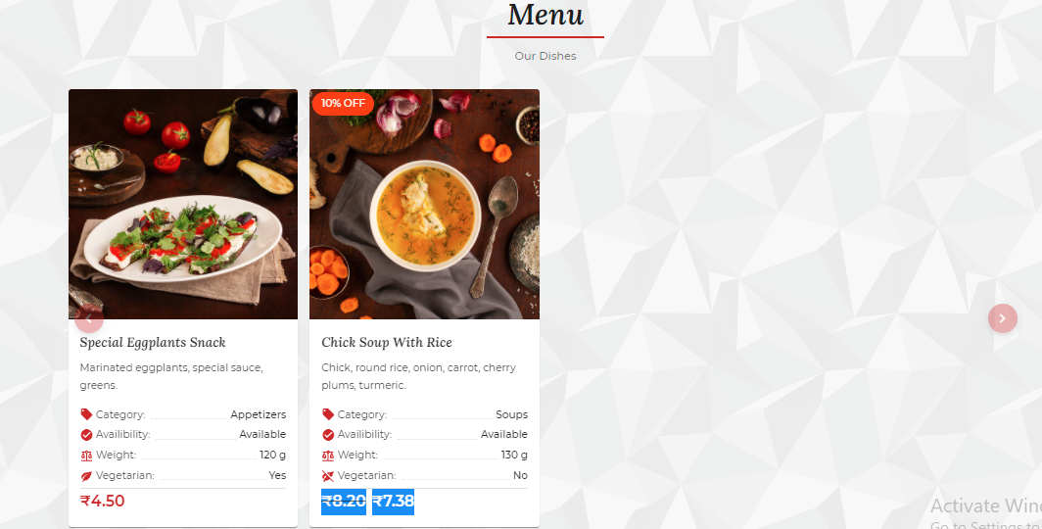

## Expected Output

## Guidelines

Add three more dishes to the Carousel.

Use a combination of Pages/home.component ,appService and JSON File to achieve it.

Use Id of 20,25 or 27 to be passed to menu/<id>

Use images available from

assets/images/foods/meat-courses,chicken-courses & desserts folders

## 

# Reach Us Implementation

## Skeleton Output

When a customer wants to reach, they can call us. This section should be shown just above the footer and below the Dish Menu (shown two menu in the skeleton)

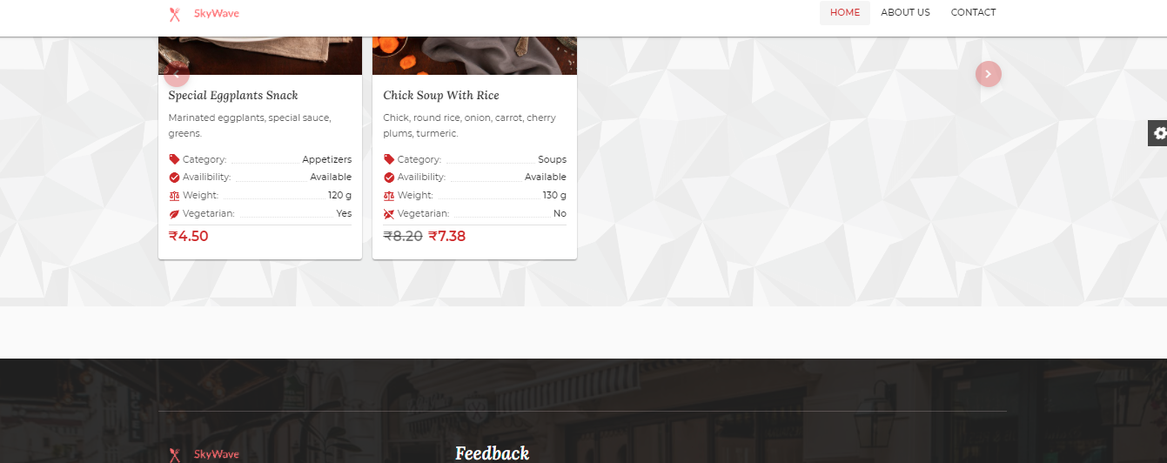

## Expected Output

## Guidelines

Modify the File: src/app/shared/get-in-touch/get-in-touch.component.html

Use the following:

1. assets/images/others/operator.png
2. mat-icon: call

# Implement Feedback/Review

When clicking the above listed dishes (two +three (you added), , it should show a new page with a detailed description of the menu. The page should also have an option to share feedback/review. This feedback is not only for that particular dish but for the entire experience of the customer.

When you click the Dish Name (highlighted in the above image), it should show a detail page of the menu with review section below

Menu Page (Detail Page,When click from Home Menu Carousel)

It should show the Dish Menu with detail along with a text on the Right side of the dish

Come and Taste the Food at our Restaurant

Don't like our food. Share your feedback!

Love to listen.....!

Visit us, today!

Review with a header “Leave a Reply” and Submit Review Button. Do the form validation and store the result in JSON

Expected Output

## Guidelines

In review Section, submit the form using API call

localhost:8080/savereview by passing the following values in JSON.

"rate" : values.rate,

"review" : values.review,

"name": values.name,

"email" : values.email

}

Use shared/comments component for this.

Use Method onCommentFormSubmit() for this to achieve it.

The API call shall return Success if information gets stored using the server service.

On Success, redirect the user to the home page.

# MENU BAR

Menu BAR with Icons are available for you to start but with template pages linked to About Us and Contact options as shown in the image below.

1. ABOUT US
2. CONTACT

When we click Logo/Skywave or Home, it should show Home Page. When we click ABOUT US/CONTACT US, it should show respective pages with its contents.

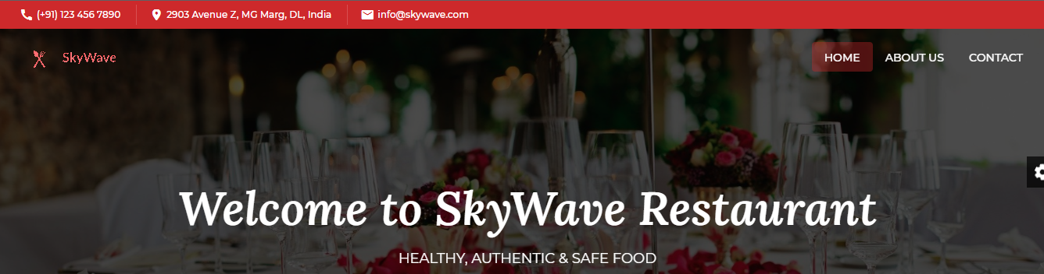

# Implement Contact Page

## 

## Skeleton Output

When a customer wants to connect with us, they can do it in various ways like calling us, sending mail or using the address to reach.

Develop this page as per the expected output shown below

This page shall only have the header and footer blocks and the expected output to be achieved.

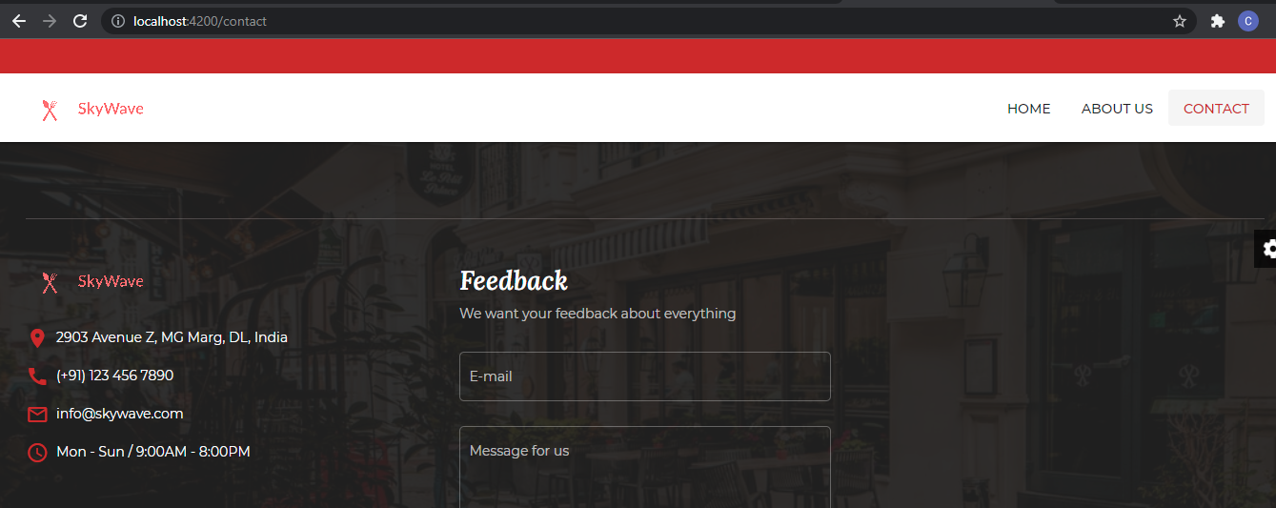

## 

## Expected Output

## Guidelines

Use

assets/images/others/contact.jpg & about-1.jpg,

app/pages/contact

shared/header-image component

mat-icon,

mat-form-field,

mat-label and

achieve the layout required.

# 

# Implement About Us Page

## 

## Skeleton Output

This page shall only have the header and footer blocks and with the contents provided the expected output to be achieved.

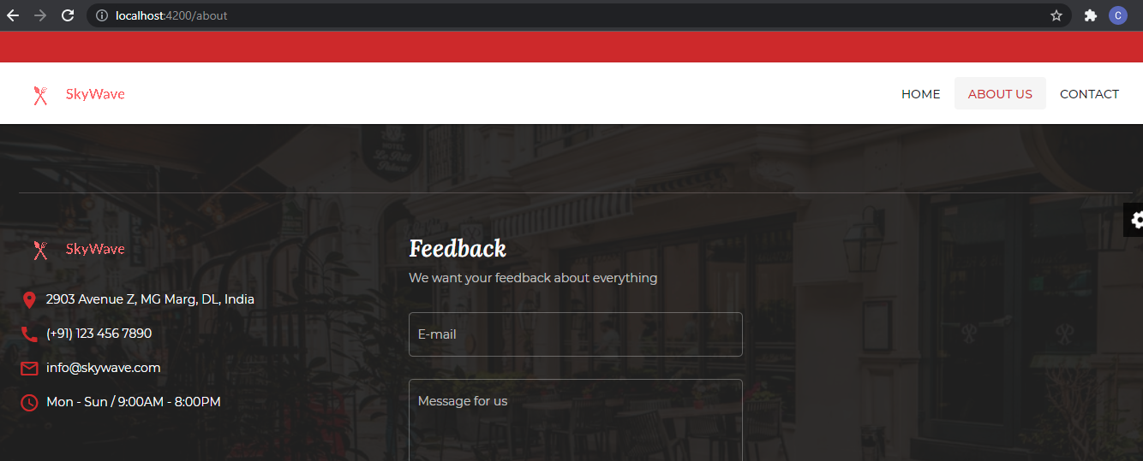

## Expected Output

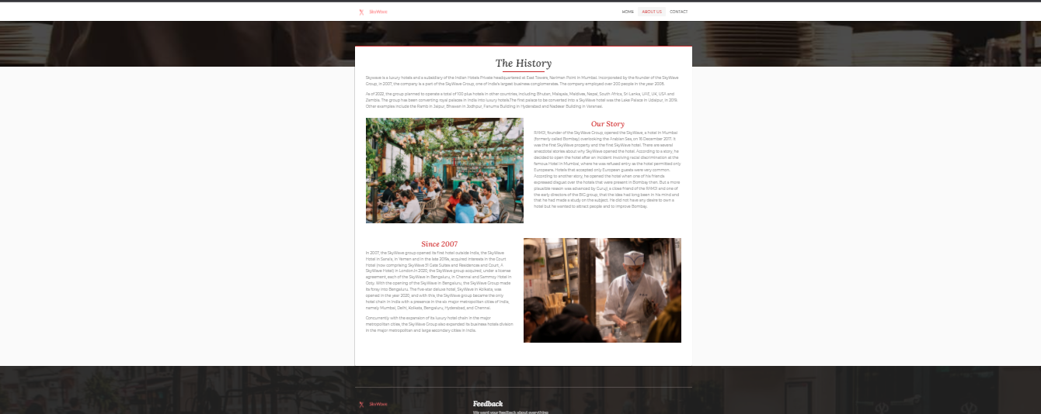

# 

# 

## Guidelines

Use

assets/images/others/about.jpg,about-1.jpg, about-2.jpg

shared/header-image component

app/pages/about

mat-icon,

mat-label and

achieve the layout required.

# Contents for About pages:

## ===>About Us

Restoring authenticity to food from the ground up is the mission that drives us. Restauration is the realization of a dream.

## ===>The History

Skywave is a luxury hotel and a subsidiary of the Indian Hotels Private headquartered at East Towers, Nariman Point in Mumbai. Incorporated by the founder of the SkyWave Group,  in 2007, the company is a part of the SkyWave Group, one of India's largest business conglomerates. The company employed over 200 people in the year 2008.

As of 2022, the group planned to  operate a total of 100 plus hotels in other countries, including Bhutan, Malaysia, Maldives, Nepal, South Africa, Sri Lanka, UAE, UK, USA and Zambia. The group has been converting royal palaces in India into luxury hotels.The first palace to be converted into a SkyWave hotel was the Lake Palace in Udaipur, in 2019. Other examples include the Ramb  in Jaipur, Bhawan in Jodhpur, Fanuma Building  in Hyderabad and Nadesar Building  in Varanasi.

It is said that RAMJI had travelled to places like London, Paris, Berlin, and othe countries to arrange for materials and pieces of art, furniture and other interior decor for his hotel. The SkyWave  group has since then developed and flourished, under the SkyWave.

## ===>Our Story

RAMJI, founder of the SkyWave Group, opened the SkyWave, a hotel in Mumbai (formerly called Bombay) overlooking the Arabian Sea, on 16 December 2017. It was the first SkyWave property and the first SkyWave hotel. There are several anecdotal stories about why SkyWave opened the hotel. According to a story, he decided to open the hotel after an incident involving racial discrimination at the famous Hotel in Mumbai, where he was refused entry as the hotel permitted only Europeans.  Hotels that accepted only European guests were very common. According to another story, he opened the hotel when one of his friends expressed disgust over the hotels that were present in Bombay then. But a more plausible reason was advanced by Guruji, a close friend of the RAMJI and one of the early directors of the BIG group, that the idea had long been in his mind and that he had made a study on the subject. He did not have any desire to own a hotel but he wanted to attract people and to improve Bombay.

## ===>Since

In 2007, the SkyWave group opened its first hotel outside India, the SkyWave  Hotel in Sana'a, in Yemen and in the late 2019s, acquired interests in the Court Hotel (now comprising SkyWave  51 Gate Suites and Residences and  Court, A SkyWave  Hotel) in London.In 2020, the SkyWave  group acquired, under a license agreement, each of the SkyWave in Bengaluru, in Chennai and Sammoy Hotel in Ooty. With the opening of the SkyWave in Bengaluru, the SkyWave Group made its foray into Bengaluru. The five-star deluxe hotel, SkyWave in Kolkata, was opened in the year 2020, and with this, the SkyWave group became the only hotel chain in India with a presence in the six major metropolitan cities of India, namely Mumbai, Delhi, Kolkata, Bengaluru, Hyderabad, and Chennai.

Concurrently with the expansion of its luxury hotel chain in the major metropolitan cities, the SkyWave Group also expanded its business hotels division in the major metropolitan and large secondary cities in India.

During the 2020s, the SkyWave Group continued to expand its geographic and market coverage in India. It developed specialized operations (such as wildlife lodges) and consolidated its position in established markets through the upgrading of existing properties and development of new properties.

(Menu detail)

Come and Taste the Food at our Restaurant

Don't like our food. Share your feedback!

Love to listen.....!

Visit us, today!

# Unit Test:

All angular components (component, service, directive etc) should have minimum **80%** code. Ensure that **Lines and Statements** code coverage individual should not be less than **80%**.

All angular components must have individual spec file associated with component file.

run below command to generate coverage report:

**ng test –code-coverage**

expected output

on application root folder inside **coverage** folder index.html as coverage report should generate which reflects required % as mentioned above as sample

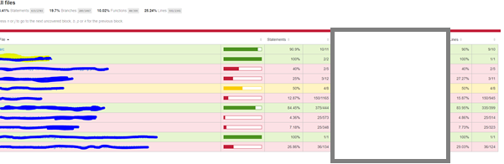

# Responsive Requirements:

* + - 1. Application should be responsive which means the screen layout will adjust on mobile and Tab screen without element overlap
      2. Application should run on mobile browsers (ios and Android) (Chrome at least)
      3. On running on mobile browser or tab screen should not have horizontal scrollbar
      4. Application layout should follow **Mobile first approach**
      5. Application layout should adjust as free flow (Left to Right) additional element wrap downside.
      6. In mobile screen single column layout
      7. More than 600 2 columns and after 700px as desktop layout.